1. Use Proc GLM to gets which independent variable is necessary for the model

**Proc** **glm** data=Price_model_table;

class state;

model HP =HPI HHI Mortgage_rate Unemp_rate state;

**run**;

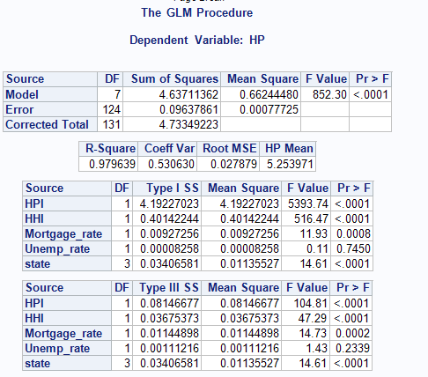

It shows that unemployment rate is not significant for the house price model compared with other factor. In order to get a better model, remove this economic factor from liner regression model

1. Repeat the liner regression model for 4 states
2. CA

**proc** **reg** data=CA_model;

model HP=HHI HPI Mortgage_rate;

**run**;

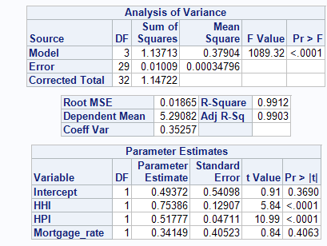

1. IL

**proc** **reg** data=IL_model;

model HP=HHI HPI Mortgage_rate;

**run**;

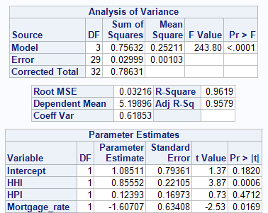

1. NY

**proc** **reg** data=NY_model;

model HP=HHI HPI Mortgage_rate;

**run**;

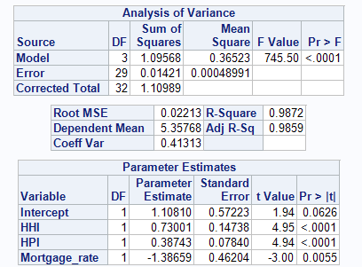

1. NC

**proc** **reg** data=NC_model;

model HP=HHI HPI Mortgage_rate;

**run**;

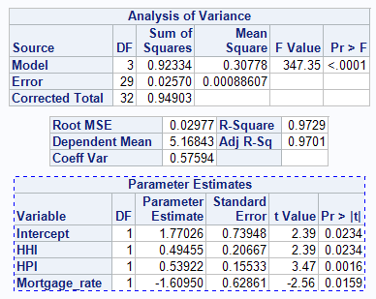

The final rank for the relationship between House price and House hold income is obvious: IL>CA > NY>NC